Power Point ideas

PowerPoint Ideas

Take a hike is our idea

This is a national level for the whole world not just the US so the hiking trails in swiss national park are in there also the great trails in US are listed

Planning for a trip and plan the hike of unusual locations.

How long does it take to hike the Grand Canyon rim to rim?

about 12-15 hours

Many will ask us the time it will take to complete a Rim to Rim hike, especially hikers that plan on taking it on in **one day**. The time varies based on one's overall conditioning, route taken, food and water breaks, weather, etc. but on average a Rim to Rim hike of the Grand Canyon takes **about 12-15 hours** to complete.

What is the hardest trek in the world?

Where can I go hiking in January?

Where can I go hiking in the winter?

Top bucket list

Hardest

Classic

Narrowed by state or the country or based on your address

Features to see: waterfalls. natural bridges, hot springs

Best day hike 1-2 hours, 4-6 hours, 8-10 hours, days with camping

National parks

Filters trails based on difficulty, location, time distance

Save trails as favorites and share with friends

Find nearby trails using your phone’s gps

Most beautiful trails

Most dangerous trails

**Trail ratings**

Easy: walking with no obstacles and low grades

Easy/intermediate

Intermediate: 10% grade, small rocks and roots, easy scrambling

Intermediate/difficult

Difficult: 15% grade, large obstacles, possible scrambling or climbing

Extremely difficult 20% grade, 15+” obstacles, many harder sections

Name of trail, location, distance, time, best time to go

Features bluebonnets. Flowering saguaros from mid May to mid June Fall leaves turning.

Map that shows trail length

latitude and longitude for starting location

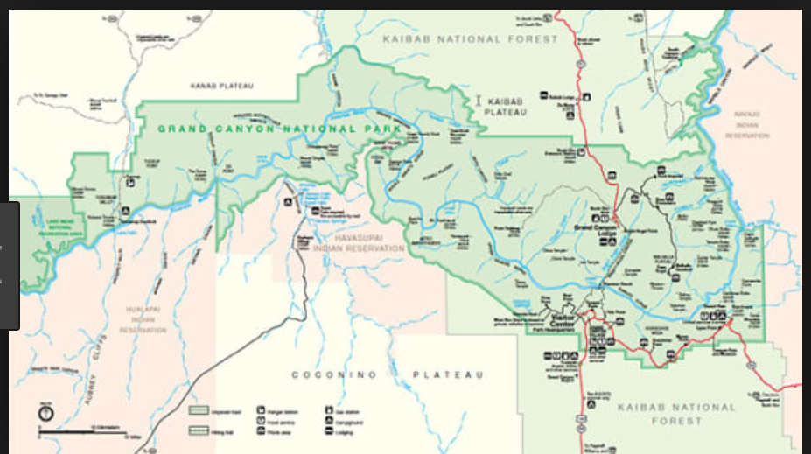

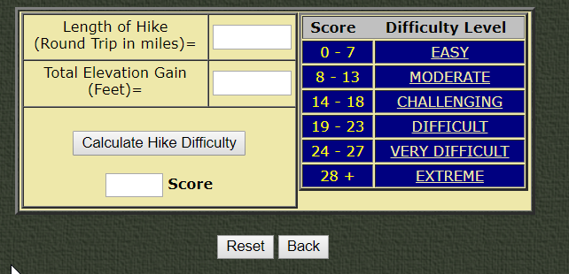

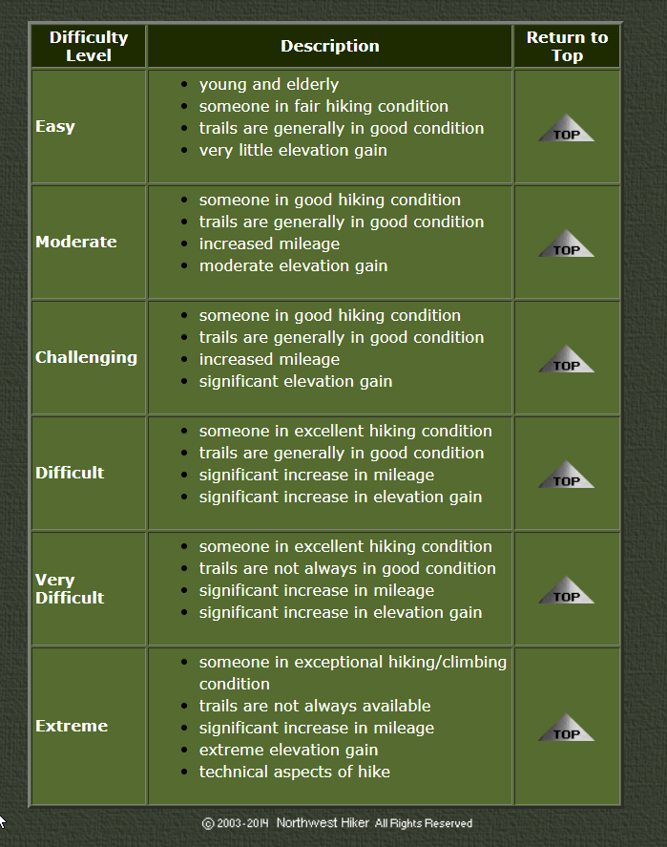

<http://www.nwhiker.com/HikeEval.html>

**pages**

Why we chose hiking?

There is no better way to enjoy nature than to hike trails. To full appreciate your surroundings, you must take it in slowly. The sights, the sounds and the smells of nature cannot be absorbed in an air-conditioned car traveling 80 miles an hour. You must fully engage your senses to your surroundings to get the peace and tranquility that only a hike can give. To decompress from life, you must slow down and spend time in nature. And we can make it easier with our “Take A Hike” app to help you plan and record your experiences. Walk through the interesting paths of life. See the sights that are not available on any road. And take a hike!

Sign in page and hiking photo

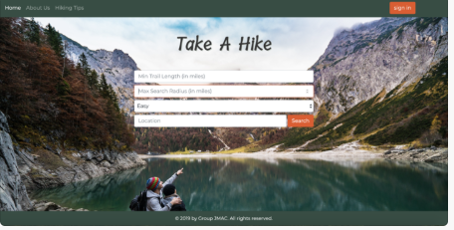

* First time sign in
* Coming back saved info- shorter sign in

Second page of hiking Main page

* Icons for other pages
* Questions customer need to answer for hike parameters

Other pages

* Difficulty calculator
* Map with hiking path marked on page
* Preparing for the hike based on group going, duration, time of year and weather conditions.
* Saved hikes with location name, date and time of day, weather conditions and distance. Important notes about the hike: rate hike difficulty. How you felt after hike. Was it too difficult, fun or not challenging enough? What time of the year did you go? Was it too cold, too hot, rainy, snowy, damp? When is the best time of year to hike this location? When is not the best time?

Project parameters needed for project 2

* <https://www.hikingproject.com/>
* zipcode npm
* use cookies for sign in
* Handlebars
* <https://maps.googleapis.com/maps/api/geocode/json?latlng> google maps supply latitude and longitude coordinates.

meet the team

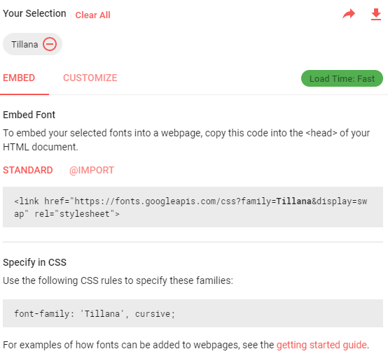

tillana

<link href="https://fonts.googleapis.com/css?family=Tillana&display=swap" rel="stylesheet">

font-family: "tillana", cursive;